**PRACTICE REPORT**

**Subject: Web application**

**Lab 1: HTML/CSS**

*Instructor: Trần Vĩnh Khiêm*

*Report date: 19/10/2023*

1. **GENERAL INFORMATION:**

Class: MSIS207.O12.CTTT.1

|  |  |  |  |
| --- | --- | --- | --- |
| **No** | **Name** | **Student ID** | **Email** |
| 1 | Nguyễn Văn Trường Khoa | 20521472 | [20521472@gm.uit.edu.vn](mailto:20521472@gm.uit.edu.vn) |
| 2 |  |  |  |

## DETAILED REPORT

**Link Github contain code:**

<https://github.com/KRocker3512/Web-app-practice-class>

**Exercise 1.**

1. **Basic, list**

|  |  |
| --- | --- |
|  |  |

**Image 1**. First code execute in browser of basic, list concept.

|  |  |
| --- | --- |
|  |  |

**Image 2**. Second code execute in browser of basic, list concept.

|  |  |
| --- | --- |
|  |  |

**Image 3**. Third code execute in browser of basic, list concept.

1. **Table**

|  |  |
| --- | --- |
|  |  |

**Image 4**. Code execute in browser of table concept.

1. **Form**

|  |
| --- |
|  |
|  |

**Image 5**. Code execute in browser of form concept.

**Exercise 2.**

Code:

|  |
| --- |
| <!DOCTYPE HTML PUBLIC "-//IETF//DTD HTML 2.0//EN">  <HTML>  <HEAD>  <TITLE>Nguyễn Văn Trường Khoa</TITLE>  <link REL="SHORTCUT ICON" HREF="images/cormen-tiny.jpg">  <style>      img {          overflow-clip-margin: content-box;          overflow: clip;      }  </style>  </HEAD>  <BODY TEXT="#000068" LINK="#060FDF" VLINK="#060FDF" ALINK="#DC24C5" BGCOLOR="#FFFFFF">  <!-- <TABLE CELLPADDING="10" CELLSPACING="0" WIDTH="475"> -->  <TABLE CELLPADDING="10" CELLSPACING="0">  <TR VALIGN=TOP>  <TD ALIGN=LEFT VALIGN=TOP WIDTH=151>  <IMG SRC="../Public/kedi1.png" height="220px" width="190px"><P>  </TD>  <TD ALIGN=LEFT VALIGN=TOP>  <H2>Nguyễn Văn Trường Khoa<br>  College Student, Information System major<br>  University of Information Technology, Ho Chi Minh City<br>  </H2>  <h3>  I was a student who was tormented by the many assignments my teacher assigned  </h3>  <!-- <p><strong>Update June 2022: I am a Democratic candidate for the New -->  <!-- Hampshire House of Representatives, running in Lebanon Ward 3 (Grafton -->  <!-- County District 15).<br> -->  <!-- <a href="https://cormenfornh.com">Campaign website</a> -->  <!-- </strong> </p> -->  <p>  Student, <A HREF="https://www.uit.edu.vn/">University of Information Technology</A>, Ungraduate.<P>  <DD>  <B>  <IMG SRC="https://www.cs.dartmouth.edu/~thc/images/yellowsq.gif" ALT="*" WIDTH=9 HEIGHT=9 ALIGN=center>    <A HREf="papers.html">Papers</A><BR>  <IMG SRC="https://www.cs.dartmouth.edu/~thc/images/yellowsq.gif" ALT="*" WIDTH=9 HEIGHT=9 ALIGN=center>       <A HREf="http://www.cs.dartmouth.edu/FG/">FG</A>       <!-- <a href="http://www.cs.dartmouth.edu/FG/"><IMG SRC="new.gif" ALT="*" ALIGN=center border=0></a> --><br>  <IMG SRC="https://www.cs.dartmouth.edu/~thc/images/yellowsq.gif" ALT="*" WIDTH=9 HEIGHT=9       ALIGN=center>     <A HREf="software.html">Other software</A><BR>  <IMG SRC="https://www.cs.dartmouth.edu/~thc/images/yellowsq.gif" ALT="*" WIDTH=9 HEIGHT=9 ALIGN=CENTER>       <a href="cormen-vita.pdf">Vita</a>  </B>  </DL>  </TD>  </TR>  </TABLE>  <TR VALIGN=TOP>  <TD COLSPAN="2">  <hr>  <h3>Contact Information</h3>  Email:<br>  <a href="mailto:20521472@gm.uit.edu.vn">20521472@gm.uit.edu.vn</a>  <p>  V.N. Mail:<br>  The house of idiots<br>  766 Võ Văn Kiệt street<br>  District 5<br>  Ho CHi Minh City  <p>  <P><HR SIZE=4>  <H4>  <IMG ALIGN="MIDDLE" SRC="https://www.cs.dartmouth.edu/~thc/images/Dtree.gif" WIDTH=34 HEIGHT=39>  <A HREF="/">Back to Dartmouth Computer Science Home Page</A>  </H4>  </TD>  </TR>  <hr>  <address><a href="./exercise2.html">Nguyễn Văn Trường Khoa &lt;20521472@gm.uit.edu.vn&gt;</a></address>  </body> </html>  </BODY>  </HTML> |

Demo:

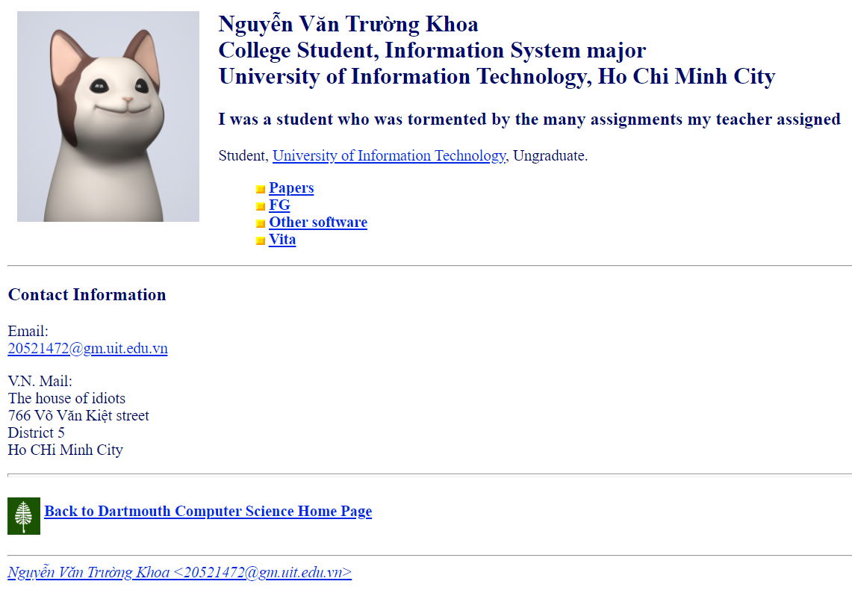

**Image 6**. Code execute in browser of exercise 2.

**Exercise 3.**

Code :

Html:

|  |
| --- |
| <!DOCTYPE html>  <html lang="en">  <head>      <meta charset="UTF-8">      <meta name="viewport" content="width=device-width, initial-scale=1.0">      <title>Document</title>      <link rel="stylesheet" href="./excercise3.css">  </head>  <body>      <div id="block-views-hien-thi-bai-viet-moi-block" class="clearfix block block-views">     <h2>THÔNG BÁO CHUNG</h2>          <div class="content"> <div class="view view-hien-thi-bai-viet-moi view-id-hien_thi_bai_viet_moi view-display-id-block view-dom-id-44700319b71fde5accf65547a64a6ec5">            <div class="view-content">          <div class="item-list">    <ul>          <li class="views-row views-row-1 views-row-odd views-row-first">              <a href="https://student.uit.edu.vn/thongbao/ky-thi-olympic-toan-hoc-sinh-vien-va-hoc-sinh-toan-quoc-2024">Kỳ thi Olympic Toán học sinh viên và học sinh Toàn quốc 2024</a>        -              17/10/2023 - 08:07        -              <strong> <span class="marker">mới</span></strong>  </li>              <li class="views-row views-row-2 views-row-even">              <a href="https://student.uit.edu.vn/thongbao/thong-bao-vv-hoc-mon-gdqpan-cua-sv-khoa-2023">Thông báo v/v học môn GDQP&amp;AN của SV khóa 2023</a>        -              16/10/2023 - 09:38        -              <strong> <span class="marker">mới</span></strong>  </li>              <li class="views-row views-row-3 views-row-odd">              <a href="https://student.uit.edu.vn/thongbao/tuyen-sinh-khoa-hoc-tieng-nhat-mien-phi-khoa-v-va-gioi-thieu-viec-lam-tai-nhat-ban-tai-tro">Tuyển sinh Khóa học tiếng Nhật (miễn phí) Khóa V và giới thiệu việc làm tại Nhật Bản - tài trợ bởi Huredee</a>        -              13/10/2023 - 14:11        -              <strong> <span class="marker">mới</span></strong>  </li>              <li class="views-row views-row-4 views-row-even">              <a href="https://student.uit.edu.vn/thongbao/thong-bao-lich-thi-tap-trung-giua-ky-hoc-ky-1-nam-hoc-2023-2024">Thông báo lịch thi tập trung Giữa kỳ học kỳ 1 năm học 2023-2024</a>        -              10/10/2023 - 15:17  </li>              <li class="views-row views-row-5 views-row-odd">              <a href="https://student.uit.edu.vn/thongbao/thong-bao-vv-trien-khai-thanh-toan-giu-xe-may-theo-thang">Thông báo v/v triển khai thanh toán giữ xe máy theo tháng</a>        -              02/10/2023 - 15:54        -              <strong> <span class="marker">mới</span></strong>  </li>              <li class="views-row views-row-6 views-row-even">              <a href="https://student.uit.edu.vn/thongbao/ke-hoach-xet-tot-nghiep-dot-04-nam-2023-0">Kế hoạch xét tốt nghiệp đợt 04 năm 2023</a>        -              29/09/2023 - 14:43        -              <strong> <span class="marker">mới</span></strong>  </li>              <li class="views-row views-row-7 views-row-odd">              <a href="https://student.uit.edu.vn/thongbao/thong-bao-vv-cong-nhan-mon-tuong-duong-giua-cac-mon-hoc-giao-duc-chat">Thông báo V/v công nhận môn tương đương giữa các môn học Giáo dục thể chất.</a>        -              15/09/2023 - 08:15  </li>              <li class="views-row views-row-8 views-row-even">              <a href="https://student.uit.edu.vn/thongbao/thong-bao-ve-viec-thu-hoc-phi-hoc-ky-1-nh-2023-2024-trinh-do-dtdh-k2022-tro-ve-truoc">Thông báo về việc thu học phí học kỳ 1, NH 2023-2024 trình độ ĐTĐH - K2022 trở về trước</a>        -              08/08/2023 - 10:02  </li>              <li class="views-row views-row-9 views-row-odd">              <a href="https://student.uit.edu.vn/thongbao/thong-bao-tham-gia-giai-thuong-tai-nang-luong-van-can-nam-2023">Thông báo tham gia Giải thưởng tài năng Lương Văn Can năm 2023</a>        -              17/07/2023 - 10:11  </li>              <li class="views-row views-row-10 views-row-even views-row-last">              <a href="https://student.uit.edu.vn/thongbao/thong-bao-ve-viec-xet-mien-cac-mon-anh-van-1-2-va-3-dot-2-trong-hoc-ky-1-nam-hoc-2023-2024">Thông báo về việc xét miễn các môn anh văn 1, 2 và 3 đợt 2 trong học kỳ 1 năm học 2023-2024 cho sinh viên chính quy chương trình đào tạo đại trà và chương trình chuẩn</a>        -              29/09/2023 - 15:44        -              <strong> <span class="marker">mới</span></strong>  </li>          </ul></div>    </div>      <div class="more-link">      <a href="https://student.uit.edu.vn/thong-bao-chung">        Xem thêm  >></a>      </div>  </body>  </html> |

CSS:

|  |
| --- |
| .block-views .item-list ul li {      background: url(https://student.uit.edu.vn/sites/all/themes/uitpb_daa/images/list-style.png) no-repeat 0 4px;      list-style: none;      padding-left: 12px;  }  .item-list ul li {      margin: 0 0 0.25em 0em;      padding: 0;  }  .views-row {      clear: both;      margin-bottom: 1em;  }  li {      line-height: 20px;      display: list-item;      text-align: -webkit-match-parent;  }  body {      background: #E5ECF4;      font-size: 14px;      font-family: sans-serif,Arial,Helvetica;      -webkit-text-size-adjust: 100%;    }  div {      display: block;  }  #content-body .block-views{      background: none repeat scroll 0 0 #fdfdfd;      border: 1px solid #dddddd;      border-radius: 5px;      margin-bottom: 20px;      padding: 8px 10px;  }  .more-link{      clear: both;      line-height: 1.4em;      margin-bottom: 0.5em;      text-align: left;      letter-spacing: .02em;      font-weight: 600;      font-size: 12px;      font-family: sans-serif,Arial,Helvetica;      float: right;  }  .marker {      color: #f00;  }  .clearfix {      display: table;      line-height: 0;      content: "";  }  .block-views{      background: none repeat scroll 0 0 #fdfdfd;      border: 1px solid #dddddd;      border-radius: 5px;      margin-bottom: 20px;      padding: 8px 10px;  }  h2{      padding: 0 10px 7px 0;      color: #0056e0;      border-bottom: 1px solid #e6e6e6;      color: #0056e0;      font-family: "Trebuchet MS",Arial,Helvetica,sans-serif;      font-size: 16px;      font-weight: bold;      padding: 0 10px 7px 0;      text-transform: uppercase;      line-height: 25px;      text-rendering: optimizelegibility;  }  a{      color: #08c;      text-decoration: none;      list-style: none;      text-align: -webkit-match-parent;  }  a:hover {      color: #005580;  } |

Demo:

**Homework 1.**

**Homework 2.**

**Homework 3.**